Archiving iPad Files, Photos and Videos to your Ramsey Google Drive Account.
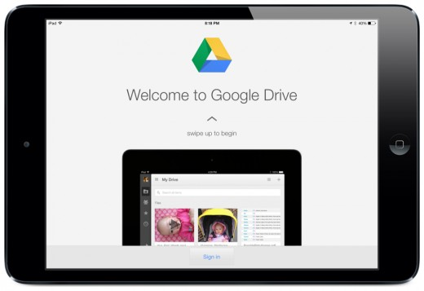
In preparation for the 2015-16 school year, it is highly recommended that you backup any files, photos and videos you may have created this school year into a folder on Google Drive. You have unlimited space on your Ramsey Google Drive. Create a folder labeled the school year or whatever you choose, and then select that folder to save to. You can then delete the files from your iPad and free up space for the following school year.

Creating Folders in Google Drive
- Open the Drive app
- Select My Drive.
- In the bottom right, touch the red + (plus) button.
- Tap Folder.
- Enter a folder name.
- Tap Create.

Backing up Photos and Videos to Google Drive
- Go to your Google Drive App.
- Tap the + in the upper right.
- Tap “Upload Photos or Videos”.
- Select your Camera Roll.
- Select the photos and videos to be uploaded.
- Tap the check in the right hand corner

Exporting Goodnotes Notebooks to Google Drive
- Create a folder in Google Drive that will be used to archive your notebooks
- Open GoodNotes
- Tap Options in the bottom right corner of the screen
- Tap Backup All
- Tap Google Drive
- Select the folder you are using to save your notebooks
- Tap Upload

